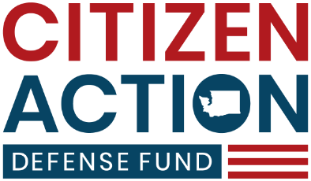

FOR IMMEDIATE RELEASE
NOVEMBER 30, 2023

CADF Files Claim for State Employee Whistleblower Who Refused to Lie About Cap and Trade Fuel Costs
The Governor’s office pressured a former state transportation employee responsible for providing economic forecasts to lie about the impact of the cap and trade program on fuel costs

Olympia, Washington — NOVEMBER 30, 2023 — The Citizen Action Defense Fund (CADF) filed a claim today on behalf of Scott Smith, who earlier this year was pressured by the Governor’s Office of Financial Management (OFM) to change the numbers in his reports that indicated that the cap and trade program was significantly impacting the cost of fuel. This occurred while the Governor was publicly accusing the fuel industry of lying about the cost of the program. When Smith refused to change his numbers, he was forced out of state service.
Smith, an economist with decades of experience, was one of the top staff members at the Washington State Department of Transportation (WSDOT) responsible for providing reports to the Transportation Revenue Forecasting Council. In January of 2023, he prepared estimates that indicated that the cap and trade program was significantly impacting the cost of fuel in Washington state. According to his whistleblower complaint, the effects were so obvious, it was a “matter of 6th grade math.” On January 18, 2023, he was told that “management” would prefer that he not include cap and trade surcharges in his quarterly fuel price forecasts. He refused to do so after repeated attempts to get him to “jimmy the numbers” in his work.
WSDOT then began an effort to drive him from state service by changing his duties, denying him a promotion, refusing to approve leave and remote work, and attempting to back date and change his job performance evaluation. After his position was eliminated, he was forced into early retirement on November 6, 2023 and filed a whistleblower complaint the same day. This morning, CADF filed a tort claim form and sent a demand letter notifying the state of his claim for $750,000.
“My client was forced out of state service for one reason: he refused to lie about the tremendous impact that cap and trade was having on fuel prices and ‘jimmy the numbers’ to support the Governor’s narrative. Whistleblower protections exist to make sure that state employees won’t be bullied by political pressure,” said Jackson Maynard, Executive Director and Counsel for CADF. “My client showed tremendous courage and integrity, and for that, he was shown the door. He lost years of wages, potential for retirement savings, and his good name was sullied. We will fight for him to get the justice he deserves for the outrageous treatment he received by the state he served so well and with such dedication.”
###

For more information:
Jackson Maynard
Executive Director, Citizen Action Defense Fund
Cell: (850) 519-3495
Email: jackson@citizenactiondefense.org

